

LABORATORY
ANATOMIC PATHOLOGY (AP) ALERTS AND COMPUTERIZED PATIENT RECORD SYSTEM (CPRS) REPORT CHANGES

USER GUIDE

PATCH LR*5.2*365

Version 5.2

August 2008

Department of Veterans Affairs
VistA Health Systems Design & Development

Preface
The Veterans Health Information Systems and Architecture (VistA) Laboratory Anatomic Pathology (AP) Alerts and Computerized Patient Record System (CPRS) Report Changes Patch LR*5.2*365 Version 5.2 User Guide provides the Department of Veterans Affairs Medical Centers (DVAMCs) Information Resource Management (IRM) and Laboratory staff with a straightforward means for using the software product.

Staffing Requirements:

IRM Staff
IRM staff is required for installing and supporting the VistA Laboratory AP Alerts and CPRS Report Changes Patch LR*5.2*365 software product.

Laboratory Staff
Laboratory staff is required for supporting and using the VistA Laboratory AP Alerts and CPRS Report Changes Patch LR*5.2*365 software product.

Intended Users:

The intended users of the VistA Laboratory AP Alerts and CPRS Report Changes Patch LR*5.2*365 software product are VA Medical Center’s laboratory staff.

VistA BLOOD BANK SOFTWARE V5.2 DEVICE PRODUCT LABELING STATEMENT

Blood Bank Clearance:

EFFECT ON BLOOD BANK FUNCTIONAL REQUIREMENTS: Patch LR*5.2*365 does not contain any changes to the VISTA BLOOD BANK Software as defined by VHA DIRECTIVE 2004-053 titled VISTA BLOOD BANK SOFTWARE VERSION 5.2.

EFFECT ON BLOOD BANK FUNCTIONAL REQUIREMENTS: Patch LR*5.2*365 does not alter or modify any software design safeguards or safety critical elements functions.

RISK ANALYSIS: Changes made by patch LR*5.2*365 have no effect on Blood Bank software functionality, therefore RISK is none.

VALIDATION REQUIREMENTS BY OPTION: Because of the nature of the changes made, no specific validation requirements exist as a result of installation of this patch.

Orientation
This section addresses package-or audience-specific notations or directions (e.g., symbols used to indicate terminal dialogues or user responses).

Screen Captures
The computer dialogue appears in Courier font, no larger than 10 points.
Example: Courier font 10 points

User Response
User entry response appears in boldface type Courier font, no larger than 10 points.
Example: Boldface type

Enter Symbol
User response to computer dialogue is followed by the <ENTER> symbol that appears in Courier font, no larger than 10 points, and bolded.
Example: <ENTER>

Tab Symbol
User response to computer dialogue is followed by the symbol that appears in Courier font, no larger than 10 points, and bolded.
Example: <Tab>

VistA Website Locations:

VistA Laboratory AP Alerts and CPRS Report Changes Patch LR*5.2*365 User Guide is accessible in Portable Document Format (PDF) and MS Word (DOC) Format at the following VistA website locations:

Laboratory Version 5.2 Home Page

http://vista.med.va.gov/ClinicalSpecialties/lab/

VistA Documentation Library (VDL)

www.va.gov/vdl/

Software and Documentation Retrieval Locations

VistA Laboratory AP Alerts and CPRS Report Changes Patch LR*5.2*365 software and user guide distributions are as follows:

NOTE: All sites are encouraged to use the File Transfer Protocol (FTP) capability. Use the FTP address “download.vista.med.va.gov” (without the quotes) to connect to the first available FTP server where the files are located.

NOTE: VistA Laboratory AP Alerts and CPRS Report Changes Patch LR*5.2*365 software is distributed by CPRS_BUNDLE_GUI_27_REQ_REL.KID host file.

OIFO’s ANONYMOUS SOFTWARE Directories:
VistA Laboratory AP Alerts and CPRS Report Changes Patch LR*5.2*365 User Guide is available at the following Office of Information Field Offices (OIFOs) ANONYMOUS.SOFTWARE directories:

OI FIELD OFFICE | FTP ADDRESS | DIRECTORY
ALBANY | ftp.fo-albany.med.va.gov | [ANONYMOUS.SOFTWARE]
HINES | ftp.fo-hines.med.va.gov | [ANONYMOUS.SOFTWARE]
SALT LAKE CITY | ftp.fo-slc.med.va.gov | [ANONYMOUS.SOFTWARE]

Documentation Retrieval Formats
VistA Laboratory AP Alerts and CPRS Report Changes Patch LR*5.2*365 documentation files are exported in the following retrieval formats:

FILE NAMES | CONTENTS | RETRIEVAL FORMATS
LAB_LR_52_365_UG.doc | USER GUIDE |  | BINARY
LAB_LR_52_365_UG.pdf | USER GUIDE |  | BINARY

Table of Contents

Preface i
Staffing Requirements: i
IRM Staff i
Laboratory Staff i
Intended Users: i
VistA BLOOD BANK SOFTWARE V5.2 DEVICE PRODUCT LABELING STATEMENT ii
Orientation iii
Screen Captures iii
User Response iii
Enter Symbol iii
Tab Symbol iii
VistA Website Locations: iii
Laboratory Version 5.2 Home Page iii
VistA Documentation Library (VDL) iii
Software and Documentation Retrieval Locations iv
OIFO’s ANONYMOUS SOFTWARE Directories: iv
Documentation Retrieval Formats iv
Introduction 7
Overview 7
Test Sites 8
Enhancements and Modifications 9
Enhancements: 9
New Application Program Interface (API) 9
New Action Alerts 9
New Send an AP Alert [LRAP ALERT] option 9
Enhanced Verify/release reports, anat path [LRAPR] option 10
Enhanced Supplementary report release, anat path [LRAPRS] option 10
Modification 10
Modified Informational Alerts 10
Modified Verify/release reports, anat path [LRAPR] option 10
Use of the Software 11
New VistA Laboratory Option: 11
Send an AP Alert [LRAP ALERT] option 11
Enhanced and Modified VistA Laboratory Options 15
1. Verify/release reports, anat path [LRAPR] option 15
2. Supplementary report release, anat path [LRAPRS] option 22
CPRS GUI Reports Tab for Anatomic Pathology Changes 31
CPRS GUI Reports Tab for Anatomic Pathology with Electronic Signature OFF 31
CPRS GUI Reports Tab for Anatomic Pathology with Electronic Signature ON 35
CPRS GUI Labs Tab and Lab Results views for Anatomic Pathology 39
CPRS GUI Reports Tab, Available Reports views for AP Supplemental Reports 42
CPRS GUI Labs Tab, Lab Results views for AP Supplemental Reports 46
Glossary 51

Introduction

Overview
VistA Laboratory Anatomic Pathology (AP) Alerts and Computerized Patient Record System (CPRS) Report Changes Patch LR*5.2*365 software release addresses 7 Patient Safety Issues (PSIs). Individual reports are displayed as one continuous scrolling display. A single row of the equal (=) sign is used to separate one report from the next. Additionally, the text- “Next SURGICAL PATHOLOGY Specimen...” is also used to separate reports. However, with multiple reports and the use of single dashed lines in each report, it can be difficult to distinguish the separation between AP reports. A new API has been created (EN^LR7OSAP4) for retrieving a detailed report for an individual Anatomic Pathology Specimen. This helps resolve the PSI by allowing a package interface, like CPRS, to present each accession and related specimens to the user and then display the related report for the accession/specimens.

Patches OR*3*210 and LR*5.2*311, implemented informational alerts generated for AP pathology results. Recipients of VA view alerts for Anatomic Pathology complained that clicking on the alert did not open up or display the report to them in the same manner as other lab alerts are displayed. Once the recipients click on the alert, it is gone from view. If they did not make a note as to who the patient was, they cannot get the alert back. Providers can easily erase the alerts without recording the patient’s name. A potential malignancy report could be missed. Problem was identified from complaints of surgeons and oncologists/hematologists. To correct this issue the new action alert is provided to display AP reports. The Anatomic Pathology informational alerts are now modified into action alerts that upon processing will direct the user to the associated report in the Clinical Reports section under the Reports tab of the CPRS GUI or to a List manager display of the associated report results.

This patch provides action alerts for Anatomic Pathology tests including Electron Microscopy (EM), Surgical Pathology (SP), Cytology (CY), and Autopsy (AU) results. These action alerts are sent automatically to the Ordering Provider, Primary Physician, or Primary Care Provider at the time the report is released. If requested, alerts may be sent to additional person(s) and mail group(s). These additional alerts are also action alerts. This functionality is now the same whether electronic signature (ES) is turned ON or OFF. Before this patch, additional alerts could not be requested with electronic signature (ES) turned OFF.

This patch provides the new Send an AP Alert [LRAP ALERT] option that is available on the Verify/release menu, anat path [LRAPVR] menu which allows a pathologist to send an action alert to a provider, other individuals, or mailgroup(s) after the report has been released. Before this software release if the user did not answer YES to the prompt to send an alert after a report was released, an alert could not be sent unless the AP report was reopened and re-released.

Test Sites

VistA Laboratory AP Alerts and CPRS Report Changes Patch LR*5.2*365 is tested by the following Veteran Affairs Medical Centers (VAMCs) and Health Care Systems (HCS):

Test Sites  (At least One Integrated Site) | Operating System Platform | Test Site Size
Charleston, SC VAMC | Cache-VMS | Large
Cleveland, OH VAMC | Cache-VMS | Large
VA Heartland-East HCS | Cache-VMS | Large/Integrated
Hudson Valley HCS | Cache-VMS | Medium/Integrated
Loma Linda, CA VAMC | Cache-VMS | Large
Northern California HCS | Cache-VMS | Large
Palo Alto HCS | Cache-VMS | Large/Integrated
Philadelphia, PA VAMC | Cache-VMS | Large
San Diego, CA VAMC | Cache-VMS | Large
Tampa, FL VAMC | Cache-VMS | Large

Enhancements and Modifications
VistA Laboratory AP Alerts and CPRS Report Changes Patch LR*5.2*365 software release contains the following enhancements and modification:

Enhancements:

New Application Program Interface (API)

1. New Application Program Interface (API) EN^LR7OSAP4 is created for retrieving a detailed Anatomic Pathology report for an individual AP specimen. This replaces the existing AP reports format within CPRS GUI Reports Tab, Available Reports, Anatomic Path Reports menu with a more clinician-friendly format.

New Action Alerts

Action alerts are automatically sent upon verification of an AP report for all four Anatomic Pathology sections (i.e., Electron Microscopy (EM), Cytology (CY), Surgical Pathology (SP), and Autopsy (AU)) as specified by the pathologist whether electronic signature is turned ON or OFF.

Action alerts are automatically sent to both the Ordering Provider (as specified for the accession) and the patient’s Primary Care Provider (PCP) (if specified) after an AP report is verified and released whether electronic signature is turned ON or OFF for any specified Anatomic Pathology section.

Action alerts displays the patient’s last name, first name, and first letter of the patient’s last name followed by the last four digits of the patient’s social security number.
Example: LRPATIENT, FOUR (L1111): Surgical Pathology results available.

New Send an AP Alert [LRAP ALERT] option
The new ‘Send an AP Alert [LRAP ALERT] option’ allows a pathologist to send an action alert to a provider, additional individuals and/or mail group(s) after an AP report is verified and released. This new option is located on the Verify/release menu, anatomic pathology [LRAPVR] menu and locked with the LRVERIFY key.

Enhanced Verify/release reports, anat path [LRAPR] option
The enhanced Verify/release reports, anat path [LRAPR] option automatically sends action alerts to the ordering provider, primary physician, and primary care provider (when specified) at the time the AP report is verified and released. This option also contains the new ‘Send the alert to additional names or mail groups? NO//’ prompt. When answered ‘YES’ at this new prompt action alerts are automatically sent to additional individuals or mail groups (i.e., as specified by the user) and a new alert message is display at this time whether electronic signature is turned ON or OFF for any specified Anatomic Pathology section.
Example: Send the alert to additional names or mail groups? NO//Yes<ENTER>
Enter name or mail group: LRA LRAPDEVELOPER, TWO
Alerts have been sent to the specified additional users.

Enhanced Supplementary report release, anat path [LRAPRS] option
The enhanced Supplementary report release, anat path [LRAPRS] option automatically sends action alerts to the ordering provider, primary physician, and primary care provider (when specified) at the time the AP report is verified and released. This option also contains the new ‘Send the alert to additional names or mail groups? NO//’ prompt. When answered “YES” at this new prompt action alerts are automatically sent to additional individuals or mail groups (i.e., as specified by the user) and a new alert message is display at this time whether electronic signature is turned ON or OFF for any specified Anatomic Pathology section.
Example: Send the alert to additional names or mail groups? NO//Yes<ENTER>
Enter name or mail group: LRA LRAPDEVELOPER, TWO
Alerts have been sent to the specified additional users.

Modification

Modified Informational Alerts

Patches OR*3*210 and LR*5.2*311 implemented informational alerts for anatomic pathology test results. Informational alerts are now modified into action alerts.

Modified Verify/release reports, anat path [LRAPR] option

The Verify/release reports, anat path [LRAPR] option is modified to remove the prompt ‘Do you wish to send an alert? NO//’ because action alert(s) are automatically sent upon verification of the AP report to the Ordering Provider (on file for the accession) and the Primary Care Provider (PCP) (if one is on file) whether the electronic signature is turned ON or OFF.

Use of the Software
This section of the VistA Laboratory AP Alerts and CPRS Report Changes Patch LR*5.2*365 User Guide contains information that allows the END USERS to accurately operate the enhanced software.

New VistA Laboratory Option:

Send an AP Alert [LRAP ALERT] option

The new ‘Send an AP Alert [LRAP ALERT] option’ allows a pathologist to send an action alert to an individual(s) or mailgroup(s) after an AP report is verified and released. The new ‘Send an AP Alert [LRAP ALERT] option’ is located on the Verify/release menu, anatomic pathology [LRAPVR].

NOTE: The new Send an AP Alert [LRAP ALERT] option is locked with the LRVERIFY key.

Example: Send an AP Alert [LRAP ALERT] option with patient’s results displayed via the View Alert option.

ANATOMIC PATHOLOGY MENU

Select Anatomic pathology Option: V<ENTER> Verify/release menu, anat path

Select Verify/release menu, anat path Option: ?<ENTER>

RR Verify/release reports, anat path
RS Supplementary report release, anat path
LU List of unverified pathology reports
CPT LAB CPT BILLING
SA Send an AP Alert

Select Verify/release menu, anat path Option: SA<ENTER> Send an AP Alert

Select ANATOMIC PATHOLOGY SECTION: ?<ENTER>
Electron Microscopy
Cytology
SURGICAL PATHOLOGY
Autopsy

Select ANATOMIC PATHOLOGY SECTION: EM<ENTER> Electron Microscopy

ELECTRON MICROSCOPY (EM)

Data entry for 2008 ? YES// <ENTER> (YES)

Select Accession Number/Pt name: 7 for 2008

LRPATIENT,ONE 000-80-1111 DOB: Oct 21, 1997
Collection Date: Mar 13, 2008@16:43
Acc #: EM 08 7

Tissue Specimen(s):
TISSUE

Alert will be sent to: LRPROVIDER, ONE

Send the alert to additional names or mail groups? NO// Y<ENTER> YES

Enter name or mail group: LRP LRPATHOLOGIST, Two LRP

Enter name or mail group: g.lmi

Enter name or mail group: <ENTER>

Alerts have been sent to the specified additional users.

Select Verify/release menu, anat path Option: <ENTER>

Select Anatomic pathology Option: <ENTER>

LRPATIENT (L1111): Electron Microscopy results available.
Enter "VA to jump to VIEW ALERTS option

Select Laboratory DHCP Menu Option: "VA<ENTER>

1. LRPATIENT (L1111): Electron Microscopy results available.
Select from 1 to 1
or enter ?, A, F, S, P, M, R, or ^ to exit: 1<ENTER>

Processing alert: LRPATIENT (L1111): Electron Microscopy results available.

Laboratory Display
Mar 14, 2008@10:55:20 Page: 1 of 4
LRPATIENT,ONE 000-80-1111 10/21/97(10)

---- ELECTRON MICROSCOPY ----

- - - - - - - - - - - - - - - - - - - - - - - - - - - - - - - - - - - - - -
MEDICAL RECORD | ELECTRON MICROSCOPY
- - - - - - - - - - - - - - - - - - - - - - - - - - - - - - - - - - - - - -
PATHOLOGY REPORT
Laboratory: BONHAM, TX Accession No. EM 08 7
- - - - - - - - - - - - - - - - - - - - - - - - - - - - - - - - - - - - - -
Submitted by: ONE Date obtained: Mar 13, 2008 16:43
- - - - - - - - - - - - - - - - - - - - - - - - - - - - - - - -- - - - - -
Specimen (Received Mar 13, 2008 16:43):
TISSUE
*+* SUPPLEMENTARY REPORT HAS BEEN ADDED *+*

+ Enter ? for more help. >>>

Mar 14, 2008@10:55:28

+ Next Screen UP Up a Line ADPL Auto Display(On/Off)
- Previous Screen DN Down a Line PS Print Screen
FS First Screen GO Go to Page PT Print Data
LS Last Screen SL Search List Q Close

Select Action: Next Screen// <ENTER> Next Screen

*+* REFER TO BOTTOM OF REPORT *+*

- - - - - - - - - - - - - - - - - - - - - - - - - - - - - - - - - - - - - -

BRIEF CLINICAL HISTORY:
- - - - - - - - - - - - - - - - - - - - - - - - - - - - - - - - - - - - - --
PREOPERATIVE DIAGNOSIS:
- - - - - - - - - - - - - - - - - - - - - - - - - - - - - - - - - - - - - -
OPERATIVE FINDINGS:
- - - - - - - - - - - - - - - - - - - - - - - - - - - - - - - - - - - - - -
POSTOPERATIVE DIAGNOSIS:

Surgeon/physician: ONE LRPROVIDER
=-=-=-=-=-=-=-=-=-=-=-=-=-=-=-=-=-=-=-=-=-=-=-=-=-=-=-=-=-=-=-=-=-=-=-=-=-=-=
- - - - - - - - - - - - - - - - - - - - - - - - - - - - - - - - - - - - - -

Mar 14, 2008@10:55:22

Enter ? for more help.

+ Next Screen UP Up a Line ADPL Auto Display(On/Off)
- Previous Screen DN Down a Line PS Print Screen
FS First Screen GO Go to Page PT Print Data
LS Last Screen SL Search List Q Close
[J

Select Action: Next Screen// <ENTER> Next Screen

PATHOLOGY REPORT
Laboratory: BONHAM, TX Accession No. EM 08 7
- - - - - - - - - - - - - - - - - - - - - - - - - - - - - - - - - - - - -
Prepared by: LRPROVIDER, ONE

TESTING

SUPPLEMENTARY REPORT(S):
Supplementary Report Date: MAR 13, 2008

/es/ LRPROVIDER TWO FOR LRPROVIDER, ONE

Mar 14, 2008@10:55:23

+ Next Screen UP Up a Line ADPL Auto Display(On/Off)
- Previous Screen DN Down a Line PS Print Screen
FS First Screen GO Go to Page PT Print Data
LS Last Screen SL Search List Q Close
[J

Select Action: Next Screen// <ENTER> Next Screen

Signed MAR 13, 2008@16:46:11
- - - - - - - - - - - - - - - - - - - - - - - - - - - - - - - - - - - - - -
(End of report
LRPROVIDER, ONE LRP| Date Mar 13, 2008
- - - - - - - - - - - - - - - - - - - - - - - - - - - - - - - - - - - - - -
LRPATIENT,ONE STANDARD FORM 515
ID:539-80-9539 SEX:M DOB:10/21/1997 AGE: 10 LOC:DERM
PCP:

Mar 14, 2008@10:55:24

Enter ? for more help.

Mar 14, 2008@10:55:24

+ Next Screen UP Up a Line ADPL Auto Display(On/Off)
- Previous Screen DN Down a Line PS Print Screen
FS First Screen GO Go to Page PT Print Data
LS Last Screen SL Search List Q Close
[J

Select Action: Close//Q<ENTER> Close

Enhanced and Modified VistA Laboratory Options

1. Verify/release reports, anat path [LRAPR] option
This option is used to verify/release pathology reports. The user is prompted for the accession number of the report to be released. If electronic signature is not activated, the user is asked if the report is to be released, yes or no. If electronic signature has been activated, the option is used to electronically sign and store pathology reports. It also allows CPT coding to be performed regardless of the release status of the chosen report. Another feature is the ability to print SNOMED codes for the given accession/report. Action alerts are sent automatically to the ordering provider and the primary physician or PCP at the time the report is released. If requested, alerts may be sent to additional person(s). These additional alerts are also action alerts. These alerts are sent whether electronic signature is on or off.

1. The ‘Verify/release reports, anat path [LRAPR] option’ is modified to remove the “Do you wish to send an alert? NO//” prompt because the new action alerts are automatically sent upon verification and release of AP reports to the ordering provider (as specified for the accession) and the primary care provider (PCP) (when specified) whether electronic signature is turned ON or OFF.

2. The ‘Verify/release reports, anat path [LRAPR] option’ is enhanced to include all four Anatomic Pathology sections (i.e., Electron Microscopy (EM), Cytology (CY), Surgical Pathology (SP), and Autopsy (AU). Previously EM and Autopsy were not included in the following AP sections:
Example: Select ANATOMIC PATHOLOGY SECTION: ?<ENTER>
Electron Microscopy
Cytology
SURGICAL PATHOLOGY
Autopsy

3. The ‘Verify/release reports, anat path [LRAPR] option’ is enhanced to automatically send action alerts upon verification and release of AP reports to both the ordering provider (as specified for the accession) and primary care provider (PCP) (when specified).whether electronic signature is turned ON or OFF.
Example: Alert will be sent to: LRORDERING PROVIDER, EIGHT
LRPRIMARY CARE PROVIDER, ONE

4. The ‘Verify/release reports, anat path [LRAPR] option’ is enhanced upon verification and release of an AP report to include the following two new prompts and a new display message whether electronic signature is turned ON or OFF.
Example: Send the alert to additional names or mail groups? NO//Yes<ENTER>
Enter name or mail group: LRA LRAPDEVELOPER, TWO
Alerts have been sent to the specified additional users.

5. The new action alerts will display the patient’s last name, first name, and first letter of the patient’s last name followed by the last four digits of the social security number.
Example: LRPATIENT, FOUR (L1111): Surgical Pathology results available.
Example #1: Verify/release reports, anat path [LRAPR] option when Electronic Signature turned ON and action alerts are automatically being sent to specified providers, additional individuals, and mail groups.

Select Anatomic pathology Option: V<ENTER> Verify/release menu, anat path

Select Verify/release menu, anat path Option: ?<ENTER>

RR Verify/release reports, anat path
RS Supplementary report release, anat path
LU List of unverified pathology reports
CPT LAB CPT BILLING
SA Send an AP Alert

Enter ?? for more options, ??? for brief descriptions, ?OPTION for help text.

Select Verify/release menu, anat path Option: Verify/release reports, anat path<ENTER>

Release/Electronically Sign Pathology Reports

Select one of the following:
C CPT Coding
E Electronically Sign Reports
V View SNOMED Codes

Selection: Electronically Sign Reports<ENTER>

Select ANATOMIC PATHOLOGY SECTION: AUTOPSY<ENTER>

AUTOPSY (NAU)

Data entry for 2008 ? YES//<ENTER> (YES)

Select Accession Number/Pt name: LRAPTEST, PATIENT LRA LRAPTEST, PATIENT
3-21-66 000-80-2222 NO NSC VETERAN
Patient LRAPTEST, PATIENT died on: 07/28/1994

Do you wish to continue with this patient [Yes/No]? YES<ENTER>
LRAPTEST, PATIENT ID: 000-80-2222

DIED Jul 28, 1994

Autopsy performed: Mar 14, 2008 Acc # NAU 08 4

Report released MAR 14, 2008@15:09:25 by LRPATHOLOGIST, TWO

Unrelease report? NO// YES<ENTER>

Enter your Current Signature Code: #### SIGNATURE VERIFIED

*** Report unreleased. ***

Select Accession Number/Pt name: 4 for 2008<ENTER>

LRAPTEST, PATIENT 000-80-2222 DOB: Mar 21, 1966
Collection Date: Jul 28, 1994
Acc #: NAU 08 4

View the report before signing? YES//<ENTER>

*** Report is being processed. One moment please. ***
NAU 08 4 - LRAPTEST, PATIENT

CLINICAL RECORD | AUTOPSY PROTOCOL
- - - - - - - - - - - - - - - - - - - - - - - - - - - - - - - - - - - -
Date died: Jul 28, 1994 | Autopsy date: MAR 14, 2008
Resident: LRPATHOLOGIST, TWO | FULL AUTOPSY Autopsy No. NAU 08 4
- - - - - - - - - - - - - - - - - - - - - - - - - - - - - - - - - - - - -

************************** MODIFIED REPORT ******************************

CLINICAL DIAGNOSIS:

- - - - - - - - - - - - - - - - - - - - - - - - - - - - - - - - - - - - -

PATHOLOGICAL DIAGNOSIS:

PATHOLOGICAL DIAGNOSES
- - - - - - - - - - - - - - - - - - - - - - - - - - - - - - - - - - - - -

Enter your Current Signature Code: #### SIGNATURE VERIFIED

*** Report is being processed for storage in TIU. One moment please. ***

*** Report storage in TIU is complete. ***

*** Report released. ***

Alert will be sent to: LRPROVIDER, FIVE

Send the alert to additional names or mail groups? NO// YES<ENTER>

Enter name or mail group: LRPRIMARYCARE, PROVIDER PCP LRPRIMARYCARE, PROVIDER <ENTER>

Enter name or mail group: G.LIM<ENTER>

Alerts have been sent to the specified additional users.

LRAPTEST, PATIENT1 (L2222): Autopsy results available.
Enter "VA to jump to VIEW ALERTS option

Select Verify/release menu, anat path Option: "VA<ENTER>

1. LRAPTEST, PATIENT1 (L2222): Autopsy results available.

Select from 1 to 1
or enter ?, A, F, S, P, M, R, or ^ to exit: 1<ENTER>

Processing alert: LRAPTEST, PATIENT1 (L2222): Autopsy results available.

Laboratory Display
Mar 20, 2008@11:14:06 Page: 1 of 5
LRAPTEST, PATIENT1 000-80-2222 3/21/66(28)

---- AUTOPSY ----

- - - - - - - - - - - - - - - - - - - - - - - - - - - - - - - - - - - - - -
CLINICAL RECORD | AUTOPSY PROTOCOL
- - - - - - - - - - - - - - - - - - - - - - - - - - - - - - - - - - - - - -
Date died: Jul 28, 1994 | Autopsy date: MAR 14, 2008
Resident: LRPATHOLOGIST, TWO | FULL AUTOPSY Autopsy No. NAU 08 4
- - - - - - - - - - - - - - - - - - - - - - - - - - - - - - - - - - - - - -

************************** MODIFIED REPORT *******************************

+ Enter ? for more help. >>>

Mar 20, 2008@11:14:068

+ Next Screen UP Up a Line ADPL Auto Display(On/Off)
- Previous Screen DN Down a Line PS Print Screen
FS First Screen GO Go to Page PT Print Data
LS Last Screen SL Search List Q Close
[J

Select Action: Next Screen//<ENTER> Next Screen

CLINICAL DIAGNOSIS:

- - - - - - - - - - - - - - - - - - - - - - - - - - - - - - - - - - - - - -

PATHOLOGICAL DIAGNOSIS:

PATHOLOGICAL DIAGNOSES
- - - - - - - - - - - - - - - - - - - - - - - - - - - - - - - - - - - - -

LRAPTEST, PATIENT1 000-80-2222 DOB: Mar 21, 1966
Acc: NAU 08 4 AUTOPSY DATA Age: 28
Date/time Died Date/time of Autopsy
Jul 28, 1994 FULL AUTOPSY MAR 14, 2008

Mar 20, 2008@11:14:088

+ Next Screen UP Up a Line ADPL Auto Display(On/Off)
- Previous Screen DN Down a Line PS Print Screen
FS First Screen GO Go to Page PT Print Data
LS Last Screen SL Search List Q Close

Select Action: Next Screen//<ENTER> Next Screen

Resident: LRPATHOLOGIST, TWO Senior: LRPATHOLOGIST, ONE

DEAD SPACE AIR
IMMUNOPEROXIDASE 3 Date: DEC 10, 2001@15:42
This is a special study. This is a special study. This is
a special study. This is a special study. This is a
special study. This is a special study. This is a special
study. This is a special study. This is a special study.
This is a special study. This is a special study. This is
a special study. This is a special study. This is a

Mar 20, 2008@11:14:098

+ Next Screen UP Up a Line ADPL Auto Display(On/Off)
- Previous Screen DN Down a Line PS Print Screen
FS First Screen GO Go to Page PT Print Data
LS Last Screen SL Search List Q Close
[J

Select Action: Next Screen// <ENTER> Next Screen

special study. This is a special study. This is a special
study. This is a special study. This is a special study.

/es/ LRPATHOLOGIST, TWO

Signed MAR 20, 2008@11:13:32
- - - - - - - - - - - - - - - - - - - - - - - - - - - - - - - - - - - - - -
| Provisional Anatomic Dx
Pathologist: LRPATHOLOGIST, TWO LRP| Date MAR 14, 2008
- - - - - - - - - - - - - - - - - - - - - - - - - - - - - - - - - - - - - -
BONHAM, TX AUTOPSY PROTOCOL
Patient: LRAPTEST, PATIENT 000-80-2222 SEX:M DOB:Mar 21, 1966

Mar 20, 2008@11:14:118

Enter ? for more help.

+ Next Screen UP Up a Line ADPL Auto Display(On/Off)
- Previous Screen DN Down a Line PS Print Screen
FS First Screen GO Go to Page PT Print Data
LS Last Screen SL Search List Q Close
[J

Select Action: Next Screen// Q Close

Example #2: Verify/release reports, anat path [LRAPR] when Electronic Signature is turned OFF and action alerts are automatically being sent to specified providers, additional individuals, and mail groups.

Select Anatomic pathology Option: V Verify/release menu, anat path<ENTER>

Select Verify/release menu, anat path Option: Verify/release reports, anat path<ENTER>

Release Pathology Reports

Select ANATOMIC PATHOLOGY SECTION: AUTOPSY<ENTER>

AUTOPSY (NAU)

Data entry for 2008 ? YES//<ENTER> (YES)

Select Accession Number/Pt name: 4 for 2008
LRAPTEST,PATIENT ID: 000-80-2222

Release report? NO// YES <ENTER>LRAPTEST,PATIENT

Report released...

Alert will be sent to: LRPRIMARYCARE, PROVIDER

Send the alert to additional names or mail groups? NO// YES<ENTER>

Enter name or mail group: LRPROVIDER, FIVE LRF <ENTER>

Enter name or mail group: G.LIM<ENTER>

Alerts have been sent to the specified additional users.

Select Accession Number/Pt name: <ENTER>

LRAPTEST,PATIENT (L2222): Autopsy results available.
Enter "VA to jump to VIEW ALERTS option

Select Verify/release menu, anat path Option: "VA<ENTER>

1. LRAPTEST, PATIENT (L2222): Autopsy results available.
Select from 1 to 1
or enter ?, A, F, S, P, M, R, or ^ to exit: 1<ENTER>

Processing alert: LRAPTEST, PATIENT (L2222): Autopsy results available.

Laboratory Display
Mar 20, 2008@11:16:39 Page: 1 of 3
LRAPTEST, PATIENT 000-80-2222 3/21/66(28)

---- AUTOPSY ----
Acc # Date/time Died Age AUTOPSY DATA Date/time of Autopsy
NAU 08 4 Jul 28, 1994 28 LRAPTEST, PATIENT Mar 14, 2008
RESIDENT PATHOLOGIST: LRPATHOLOGIST, TWO Senior: RESIDENT PATHOLOGIST: LRPATHOLOGIST, ONE

PATHOLOGICAL DIAGNOSIS:
PATHOLOGICAL DIAGNOSES

No organ weights entered.

+ Enter ? for more help. >>>

Mar 20, 2008@11:16:398

+ Next Screen UP Up a Line ADPL Auto Display(On/Off)
- Previous Screen DN Down a Line PS Print Screen
FS First Screen GO Go to Page PT Print Data
LS Last Screen SL Search List Q Close
[J

Select Action: Next Screen// <ENTER> Next Screen

DEAD SPACE AIR
IMMUNOPEROXIDASE 3 Date: Dec 10, 2001 15:42
This is a special study.
This is a special study.
This is a special study.
This is a special study.
This is a special study.
This is a special study.
This is a special study.
This is a special study.
This is a special study.
This is a special study.
This is a special study.

Mar 20, 2008@11:16:428

Enter ? for more help.

+ Next Screen UP Up a Line ADPL Auto Display(On/Off)
- Previous Screen DN Down a Line PS Print Screen
FS First Screen GO Go to Page PT Print Data
LS Last Screen SL Search List Q Close
[J

Select Action: Next Screen// Q<ENTER> Close

2. Supplementary report release, anat path [LRAPRS] option

This option releases supplementary reports for Surgical Pathology, Cytopathology, Electron Microscopy, or Autopsy. If all supplementary reports that exist for the chosen accession have already been released or if no supplementary reports exist for the accession, the user will be notified. If electronic signature is not activated, the user is asked if the report is to be released, yes or no. If electronic signature has been activated, the option is used to sign and store the supplementary report. Action alerts are sent automatically to the ordering provider and the primary physician or PCP at the time the supplementary reports are released. If requested, alerts may be sent to additional person(s). These additional alerts are also action alerts. These alerts are sent whether electronic signature is on or off.

Example #1: Supplementary report release, anat path [LRAPRS] option when Electronic Signature turned ON and action alerts are automatically being sent to specified providers and additional individuals and mail groups.

Select Data entry, anat path Option: SR<ENTER> Supplementary Report, Anat Path

Select ANATOMIC PATHOLOGY SECTION: EM <ENTER>

EM (EM)

Enter Etiology, Function, Procedure & Disease ? NO//<ENTER> (NO)

Data entry for 2008 ? YES//<ENTER> (YES)

Select Accession Number/Pt name: 6 for 2008
LRPATIENT,ONE ID: 666-66-6666
Specimen(s): <ENTER>
TISSUE

Select EM ORGAN/TISSUE: <ENTER>

This EM report has been released.
Supplementary report additions/modifications will create an audit trail.

Select SUPPLEMENTARY REPORT DATE: ^<ENTER>

Select Accession Number/Pt name: 6 for 2008
LRPATIENT,ONE ID: 666-66-6666
Specimen(s): <ENTER>
TISSUE

Select EM ORGAN/TISSUE: TISSUE<ENTER>
1 TISSUE
2 TISSUE EOSINOPHIL 05145
3 TISSUE NEUTROPHIL 05147
4 TISSUE, SUBCUTANEOUS SUBCUTANEOUS TISSUE 03000
CHOOSE 1-4: 1<ENTER> TISSUE
EM ORGAN/TISSUE NUMBER: 1//<ENTER>
Select MORPHOLOGY: n<ENTER>
1 N NEGATIVE FOR MALIGNANT CELLS 09460
2 NAIL DYSTROPHY 56500
3 NARROWING 01500
4 NAVICULAR CELL 69390
5 NECROBIOSIS 54180
Press <RETURN> to see more, '^' to exit this list, OR
CHOOSE 1-5: 1<ENTER> NEGATIVE FOR MALIGNANT CELLS 09460
Select MORPHOLOGY: <ENTER>
Select EM ORGAN/TISSUE: <ENTER>

This EM report has been released.
Supplementary report additions/modifications will create an audit trail.

Select SUPPLEMENTARY REPORT DATE: T<ENTER> MAR 20, 2008
SUPPLEMENTARY REPORT DATE/TIME: MAR 20,2008//<ENTER>
DESCRIPTION:<ENTER>
No existing text
Edit? NO// y<ENTER> YES

=========================================================================
Testing supplementary report with ES on
Do you want to save changes? yes
Saving text
=========================================================================

Select Accession Number/Pt name: <ENTER>

Select Data entry, anat path Option: <ENTER>

Select Anatomic pathology Option: v <ENTER> Verify/release menu, anat path

Select Verify/release menu, anat path Option: RS <ENTER> Supplementary report release, anat path

Release Supplementary Pathology Reports

Select ANATOMIC PATHOLOGY SECTION: EM<ENTER>

ELECTRON MICROSCOPY (EM)

Data entry for 2008 ? YES//<ENTER> (YES)

Select Accession Number/Pt name: 6 for 2008
LRPATIENT,ONE ID: 666-66-6666
Specimen(s): <ENTER>
TISSUE

Select SUPPLEMENTARY REPORT DATE: MAR 20, 2008//<ENTER> MAR 20, 2008

Enter your Current Signature Code: ##### SIGNATURE VERIFIED...Released

Alert will be sent to: LRORDERINIG, PROVIDER

Send the alert to additional names or mail groups? NO// y <ENTER> YES

Enter name or mail group: LRPRIMARYCARE, THREE LRT

Enter name or mail group: G.LIM<ENTER>

Alerts have been sent to the specified additional users.

*** Main Report Release ***

*** Report is being processed for storage in TIU. One moment please. ***

*** Report storage in TIU is complete. ***

*** Report released. ***

Select Accession Number/Pt name: <ENTER>

LRPATIENT (L6666): Electron Microscopy supplmntl rpt results available.
Enter "VA to jump to VIEW ALERTS option

Select Verify/release menu, anat path Option: "VA<ENTER>

1. LRPATIENT (L6666): Electron Microscopy supplmntl rpt results available.
Select from 1 to 1
or enter ?, A, F, S, P, M, R, or ^ to exit: 1<ENTER>

Processing alert: LRPATIENT (L6666): Electron Microscopy supplmntl rpt results available.

Laboratory Display
Mar 20, 2008@13:42:09 Page: 1 of 4
LRPATIENT,ONE 666-66-6666 10/21/97

---- ELECTRON MICROSCOPY ----

- - - - - - - - - - - - - - - - - - - - - - - - - - - - - - - - - - - - - -
MEDICAL RECORD | ELECTRON MICROSCOPY
- - - - - - - - - - - - - - - - - - - - - - - - - - - - - - - - - - - - - -
PATHOLOGY REPORT
Laboratory: BONHAM, TX Accession No. EM 08 6
- - - - - - - - - - - - - - - - - - - - - - - - - - - - - - - - - - - - - - -
Submitted by: LRPROVIDER, FOUR Date obtained: Mar 12, 2008 15:52
- - - - - - - - - - - - - - - - - - - - - - - - - - - - - - - - - - - - - - -
Specimen (Received Mar 12, 2008 15:52):
TISSUE
*+* SUPPLEMENTARY REPORT HAS BEEN ADDED *+*

+ Enter ? for more help. >>>

Mar 20, 2008@13:42:098

+ Next Screen UP Up a Line ADPL Auto Display(On/Off)
- Previous Screen DN Down a Line PS Print Screen
FS First Screen GO Go to Page PT Print Data
LS Last Screen SL Search List Q Close
[J

Select Action: Next Screen// <ENTER> Next Screen

*+* REFER TO BOTTOM OF REPORT *+*

- - - - - - - - - - - - - - - - - - - - - - - - - - - - - - - - - - - - - -
BRIEF CLINICAL HISTORY:
- - - - - - - - - - - - - - - - - - - - - - - - - - - - - - - - - - - - - -
PREOPERATIVE DIAGNOSIS:
- - - - - - - - - - - - - - - - - - - - - - - - - - - - - - - - - - - - - -
OPERATIVE FINDINGS:
- - -- - - - - - - - - - - - - - - - - - - - - - - - - - - - - - - - - - -
POSTOPERATIVE DIAGNOSIS:

Surgeon/physician: ONE LRPROVIDER
=-=-=-=-=-=-=-=-=-=-=-=-=-=-=-=-=-=-=-=-=-=-=-=-=-=-=-=-=-=-=-=-=-=-=-=-=-=
- - - - - - - - - - - - - - - - - - - - - - - - - - - - - - - - - - - - - -

Mar 20, 2008@13:42:118

Enter ? for more help.

+ Next Screen UP Up a Line ADPL Auto Display(On/Off)
- Previous Screen DN Down a Line PS Print Screen
FS First Screen GO Go to Page PT Print Data
LS Last Screen SL Search List Q Close
[J

Select Action: Next Screen// <ENTER> Next Screen

PATHOLOGY REPORT
Laboratory: BONHAM, TX Accession No. EM 08 6
- - - - - - - - - - - - - - - - - - - - - - - - - - - - - - - - - - - - - -
Prepared by: ONE LRPROVIDER

TESTING EM 08 06 ALERTS

SUPPLEMENTARY REPORT(S):
Supplementary Report Date: MAR 20, 2008
*+* SUPPLEMENTARY REPORT HAS BEEN ADDED/MODIFIED *+*
(Added/Last released: Mar 20, 2008 13:41 Signed by LRPROVIDER, FOUR)
Testing supplementary report with ES on

Mar 20, 2008@13:42

+ Next Screen UP Up a Line ADPL Auto Display(On/Off)
- Previous Screen DN Down a Line PS Print Screen
FS First Screen GO Go to Page PT Print Data
LS Last Screen SL Search List Q Close
[J

Select Action: Next Screen// <ENTER> Next Screen

/es/ LRPROVIDER, FOUR FOR LRPROVIDER, ONE

Signed MAR 20, 2008@13:41:52
- - - - - - - - - - - - - - - - - - - - - - - - - - - - - - - - - - - - - -
(End of report)
ONE LRPROVIDER cka| Date Mar 12, 2008
- - - - - - - - - - - - - - - - - - - - - - - - - - - - - - - - - - - - - -
LRPATIENT,ONE STANDARD FORM 515
ID: 666-66-6666 SEX:M DOB:10/21/1997 AGE: 10 LOC:DERM
PCP:

Enter ? for more help.

Mar 20, 2008@13

+ Next Screen UP Up a Line ADPL Auto Display(On/Off)
- Previous Screen DN Down a Line PS Print Screen
FS First Screen GO Go to Page PT Print Data
LS Last Screen SL Search List Q Close
[J

Select Action: Close// <ENTER> Close

Example #2: Supplementary report release, anat path [LRAPRS] option when Electronic Signature turned OFF and action alerts are automatically being sent to specified providers, additional individuals, and mail groups.

Select Data entry, anat path Option: ?<ENTER>

AU Data entry for autopsies ...
BS Blocks, Stains, Procedures, anat path
CO Coding, anat path ...
GD Clinical Hx/Gross Description/FS
GM FS/Gross/Micro/Dx
GS FS/Gross/Micro/Dx/SNOMED Coding
GI FS/Gross/Micro/Dx/ICD9CM Coding
OR Enter old anat path records
SR Supplementary Report, Anat Path
SS Spec Studies-EM;Immuno;Consult;Pic, Anat Path

Enter ?? for more options, ??? for brief descriptions, ?OPTION for help text.

Select Data entry, anat path Option: SR<ENTER> Supplementary Report, Anat Path
Select ANATOMIC PATHOLOGY SECTION: cyTOPATHOLOGY<ENTER>

CYTOPATHOLOGY (NCY)

Enter Etiology, Function, Procedure & Disease ? NO//<ENTER> (NO)

Data entry for 2008 ? YES// <ENTER> (YES)

Select Accession Number/Pt name: 5 for 2008
LRPATIENT,ONE ID: 666-66-6666
Specimen(s): <ENTER>
TISSUE

Select CYTOPATH ORGAN/TISSUE: TISSUE
1 TISSUE
2 TISSUE EOSINOPHIL 05145
3 TISSUE NEUTROPHIL 05147
4 TISSUE, SUBCUTANEOUS SUBCUTANEOUS TISSUE 03000
CHOOSE 1-4: 1 TISSUE<ENTER>
CYTOPATH ORGAN/TISSUE NUMBER: 1//<ENTER>
Select MORPHOLOGY: N<ENTER>
1 N NEGATIVE FOR MALIGNANT CELLS 09460
2 NAIL DYSTROPHY 56500
3 NARROWING 01500
4 NAVICULAR CELL 69390
5 NECROBIOSIS 54180
Press <RETURN> to see more, '^' to exit this list, OR
CHOOSE 1-5: 1<ENTER> NEGATIVE FOR MALIGNANT CELLS 09460
Select MORPHOLOGY: <ENTER>
Select CYTOPATH ORGAN/TISSUE: <ENTER>

This CYTOPATHOLOGY report has been released.
Supplementary report additions/modifications will create an audit trail.

Select SUPPLEMENTARY REPORT DATE: T<ENTER> MAR 20, 2008
SUPPLEMENTARY REPORT DATE/TIME: MAR 20,2008//<ENTER>
DESCRIPTION: <ENTER>
No existing text
Edit? NO// YES<ENTER>
============================================================================
DESCRIPTION: Supplemental report testing LR*5.2*365.
========T=======T=======T=======T=======T=======T=======T=======T====
Do you want to save changes? YES<ENTER>
Saving text ...

Select Accession Number/Pt name: <ENTER>

Select Data entry, anat path Option: <ENTER>

Select Anatomic pathology Option: ? <ENTER>

D Data entry, anat path ...
E Edit/modify data, anat path ...
I Inquiries, anat path ...
L Log-in menu, anat path ...
P Print, anat path ...
R SNOMED field references ...
S Supervisor, anat path ...
V Verify/release menu, anat path ...
C Clinician options, anat path ...
W Workload, anat path ...

Enter ?? for more options, ??? for brief descriptions, ?OPTION for help text.

Select Anatomic pathology Option: V Verify/release menu, anat path<ENTER>

Select Verify/release menu, anat path Option: verify/release reports, anat path<ENTER>

Release Pathology Reports

Select ANATOMIC PATHOLOGY SECTION: CYTOPATHOLOGY<ENTER>

CYTOPATHOLOGY (NCY)

Data entry for 2008 ? YES//<ENTER> (YES)

Select Accession Number/Pt name: ^<ENTER>

Select Verify/release menu, anat path Option: ? <ENTER>

RR Verify/release reports, anat path
RS Supplementary report release, anat path
LU List of unverified pathology reports
CPT LAB CPT BILLING
SA Send an AP Alert

Enter ?? for more options, ??? for brief descriptions, ?OPTION for help text.

Select Verify/release menu, anat path Option: RS Supplementary report release, anat path <ENTER>

Release Supplementary Pathology Reports

Select ANATOMIC PATHOLOGY SECTION: CYTOPATHOLOGY<ENTER>

CYTOPATHOLOGY (NCY)

Data entry for 2008 ? YES// <ENTER> (YES)

Select Accession Number/Pt name: 5 for 2008
LRPATIENT,ONE ID: 666-66-6666
Specimen(s): <ENTER>
TISSUE

Select SUPPLEMENTARY REPORT DATE: MAR 20, 2008// <ENTER> MAR 20, 2008

Release supplementary report? NO// y YES...Released<ENTER>

Alert will be sent to: LRPROVIDER, ONE

Send the alert to additional names or mail groups? NO// y YES<ENTER>

Enter name or mail group: G.LIM <ENTER>

Enter name or mail group: <ENTER>

Alerts have been sent to the specified additional users.

*** Main Report Has Been Released ***

Select SUPPLEMENTARY REPORT DATE: <ENTER>

Select Accession Number/Pt name: <ENTER>

LRPATIENT (L6666): Cytology supplmntl rpt results available.
Enter "VA to jump to VIEW ALERTS option

Select Verify/release menu, anat path Option: "VA<ENTER>

1. LRPATIENT (L6666): Cytology supplmntl rpt results available.
Select from 1 to 1
or enter ?, A, F, S, P, M, R, or ^ to exit: 1<ENTER>

Processing alert: LRPATIENT (L9539): Cytology supplmntl rpt results available.

Laboratory Display
Mar 20, 2008@13:39:16 Page: 1 of 2
LRPATIENT,ONE 666-66-6666 10/21/97(10)

---- CYTOPATHOLOGY ----
Date Spec taken: Mar 12, 2008 15:54 Pathologist:ONE LRPROVIDER
Date Spec rec'd: Mar 12, 2008 15:55 Tech: TWO LRPROVIDER
Date completed: Mar 12, 2008 Accession #: NCY 08 5
Submitted by: ONE Practitioner: ONE LRPROVIDER
---------------------------------------------------------------------------
Specimen:
TISSUE
*+* SUPPLEMENTARY REPORT HAS BEEN ADDED *+*
*+* REFER TO BOTTOM OF REPORT *+*

CYTO TESTING AP ALERTS WITH ES OFF 3/12/08
Supplementary Report:

+ Enter ? for more help. >>>

Mar 20, 2008@13:39:16

+ Next Screen UP Up a Line ADPL Auto Display(On/Off)
- Previous Screen DN Down a Line PS Print Screen
FS First Screen GO Go to Page PT Print Data
LS Last Screen SL Search List Q Close
[J

Select Action: Next Screen// <ENTER> Next Screen

Date: Mar 20, 2008
*+* SUPPLEMENTARY REPORT HAS BEEN ADDED/MODIFIED *+*
(Added/Last modified: Mar 20, 2008 13:38 signed by LRPROVIDER, ONE)
Supplemental report testing LR*5.2*365

Enter ? for more help.

Mar 20, 2008@13:39:218

+ Next Screen UP Up a Line ADPL Auto Display(On/Off)
- Previous Screen DN Down a Line PS Print Screen
FS First Screen GO Go to Page PT Print Data
LS Last Screen SL Search List Q Close
[J

Select Action: Close//<ENTER> Close

CPRS GUI Reports Tab for Anatomic Pathology Changes

CPRS GUI Reports Tab for Anatomic Pathology with Electronic Signature OFF

The following Reports tab views are for Cytopathology, Surgical Pathology, Electron Microscopy, and Autopsy with Electronic Signature turned OFF.

Example: CYTOPATHOLOGY Report with ES OFF

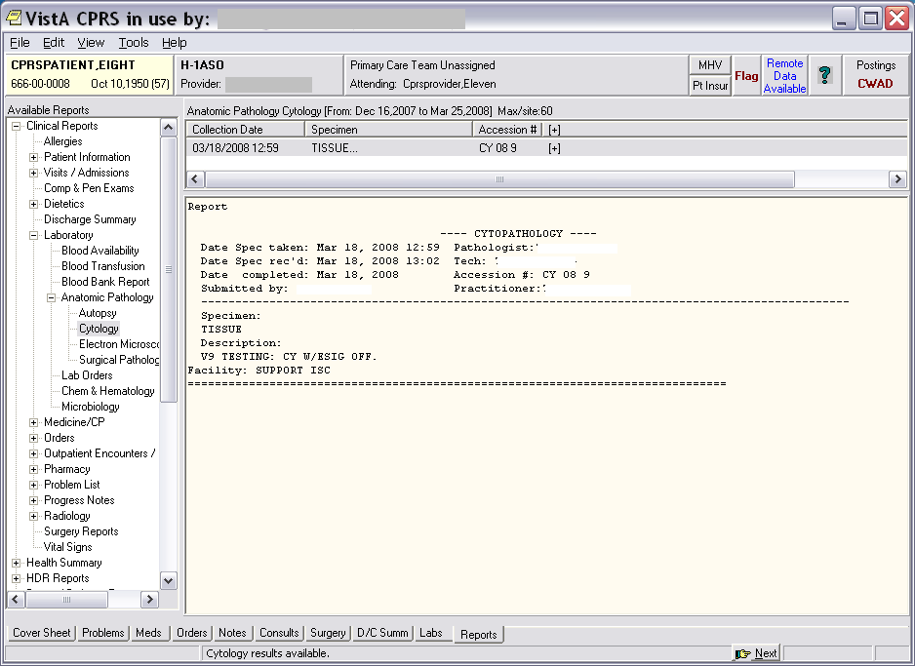
Example: SURGICAL PATHOLOGY Report with ES OFF

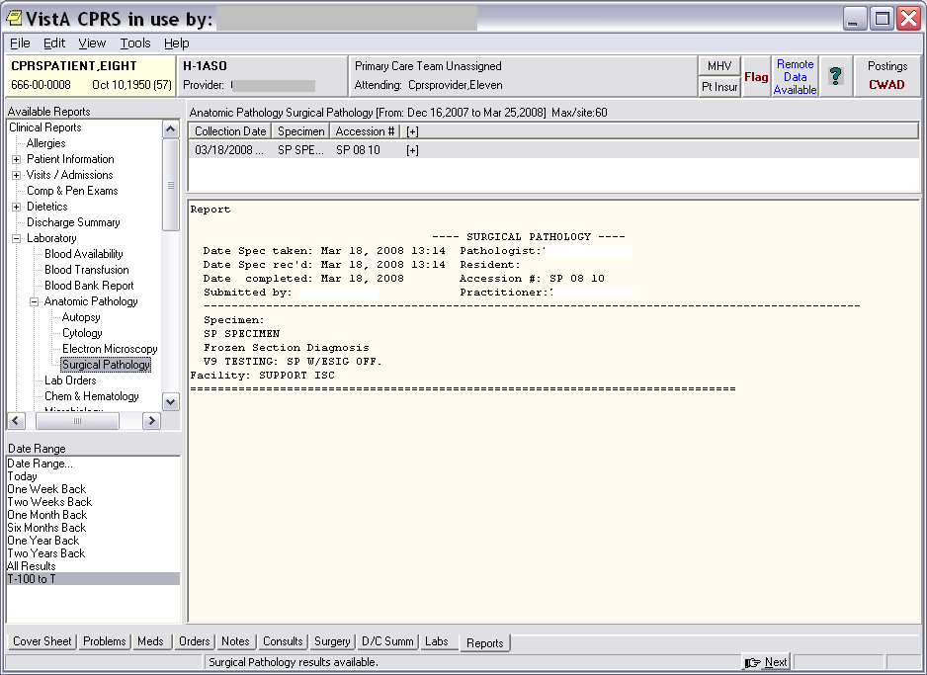
Example: ELECTRON MICROSCOPY Report with ES OFF

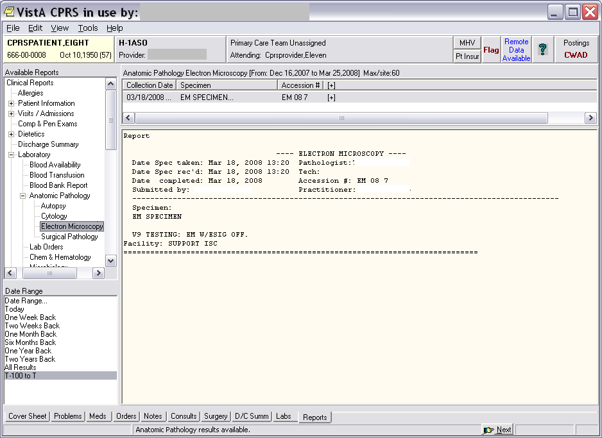
Example: AUTOPSY Report with ES OFF

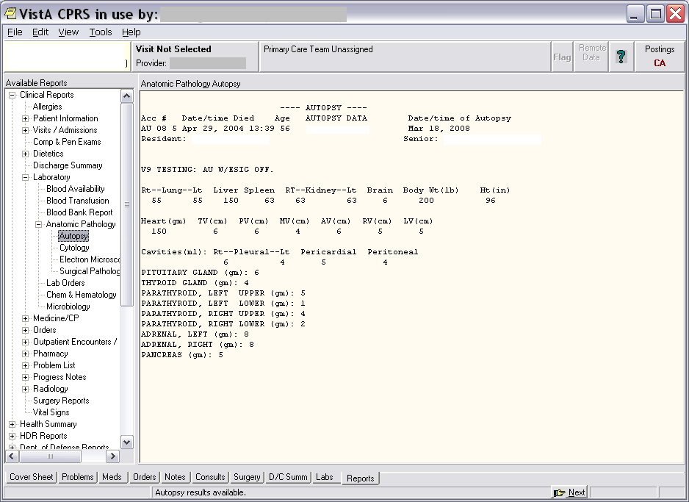

CPRS GUI Reports Tab for Anatomic Pathology with Electronic Signature ON

Reports tab views for Cytopathology, Surgical Pathology, Electron Microscopy, and Autopsy with Electronic Signature turned ON.

Example: CYTOPATHOLOGY Report with ES ON

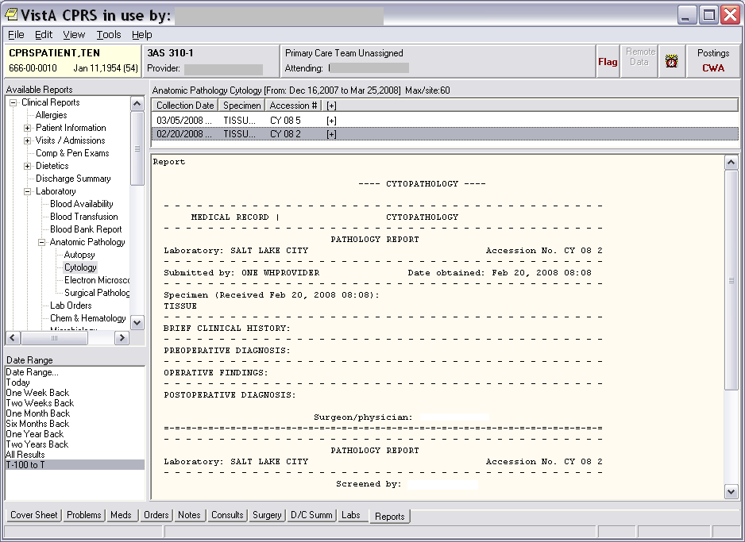
Example: SURGICAL PATHOLOGY Report with ES ON

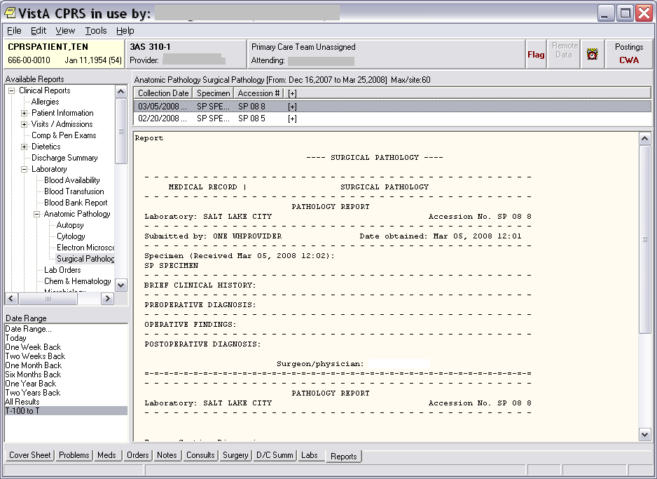
Example: ELECTRON MICROSCOPY Report with ES ON

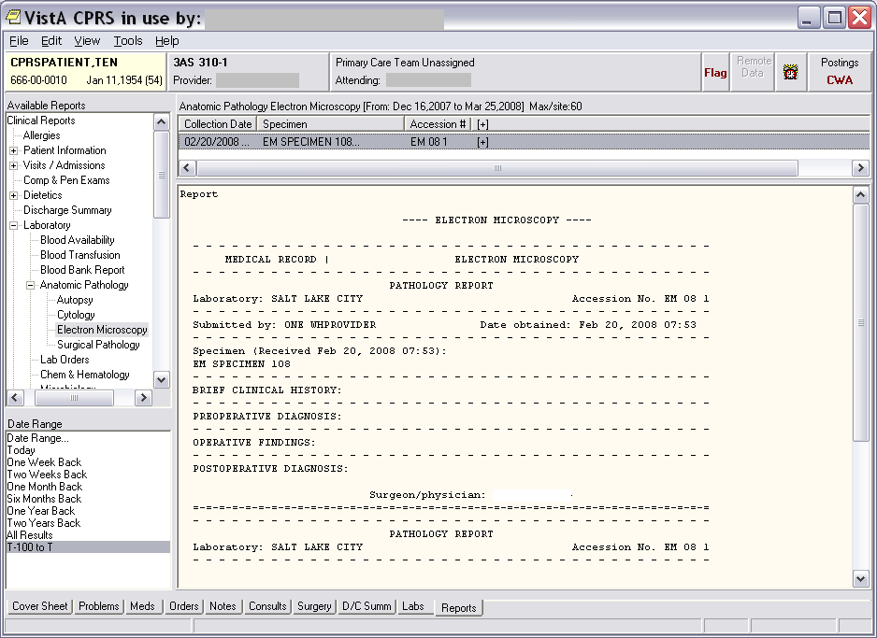
Example: AUTOPSY with SUPPLEMENTARY Report added and ES ON.

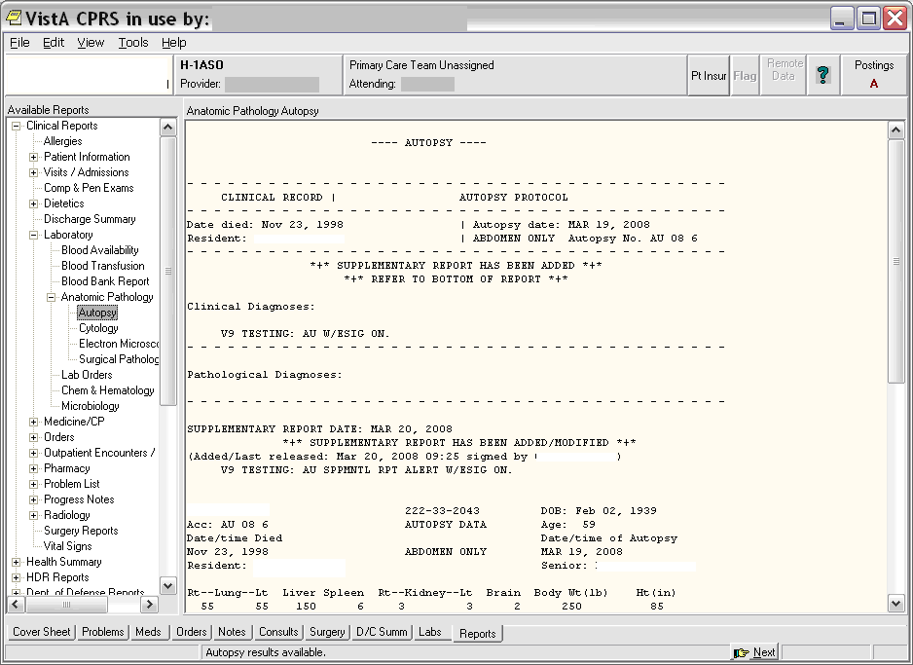

CPRS GUI Labs Tab and Lab Results views for Anatomic Pathology

The following examples are displaying Labs Results for Cytopathology, Surgical Pathology, and Electron Microscopy reports by Date Ranges:

Example: Labs Results for CYTOPATHOLOGY report by Date Range.

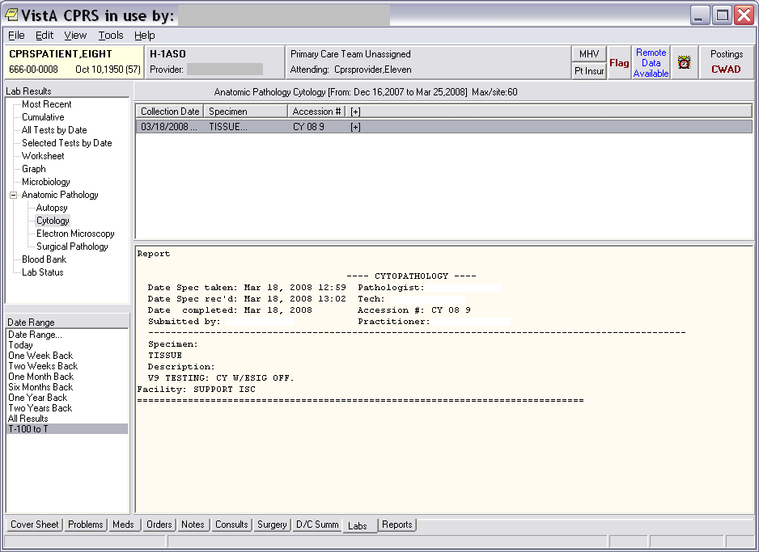
Example: Labs Results for SURGICAL PATHOLOGY report by Date Range

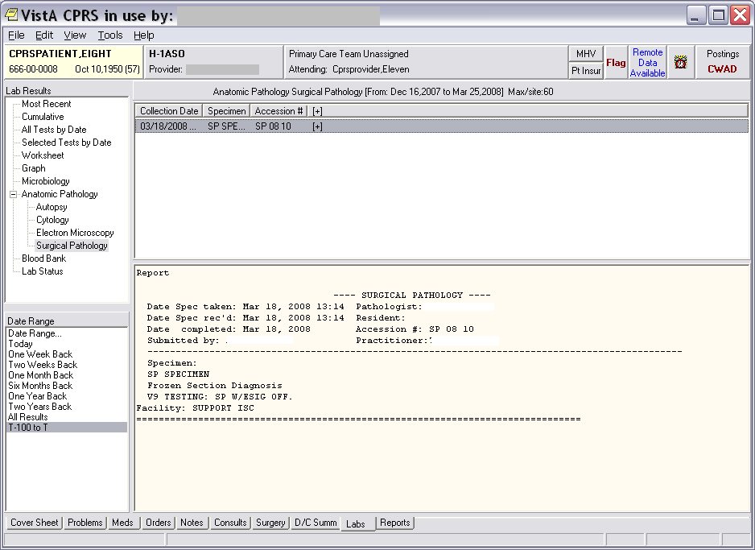
Example: Labs Results for ELECTRON MICROSCOPY report by Date Range.

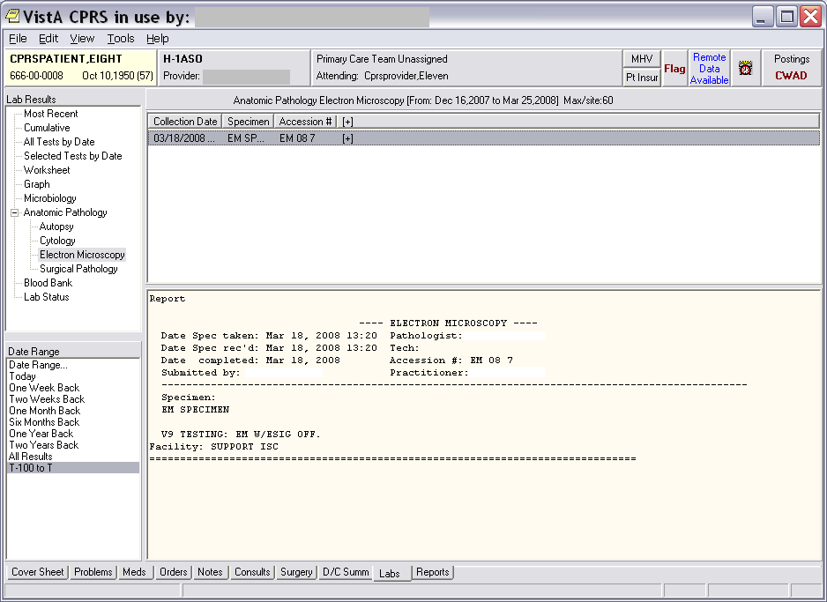

CPRS GUI Reports Tab, Available Reports views for AP Supplemental Reports

The following examples are displaying the Report Tab, Available Reports menu, for Cytopathology, Surgical Pathology, and Electron Microscopy Reports when a SUPPLEMENTARY REPORT has been added to a report:

Example: CYTOPATHOLOGY displaying a SUPPLEMENTARY REPORT that has been added with ES ON, YES to sending alerts to additional users, and a SUPPLEMENTARY REPORT has been Added/Modified.

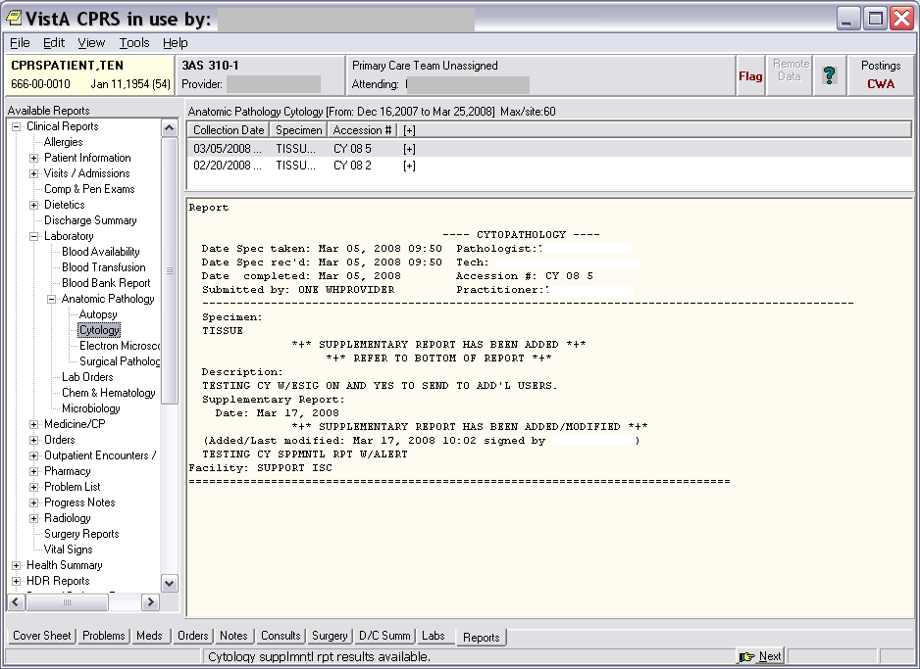
Example: ELECTRON MICROSCOPY displaying a SUPPLEMENTARY REPORT that has been added with ES OFF, NO to sending alerts to additional users, and a SUPPLEMENTARY REPORT has been Added/Modified.

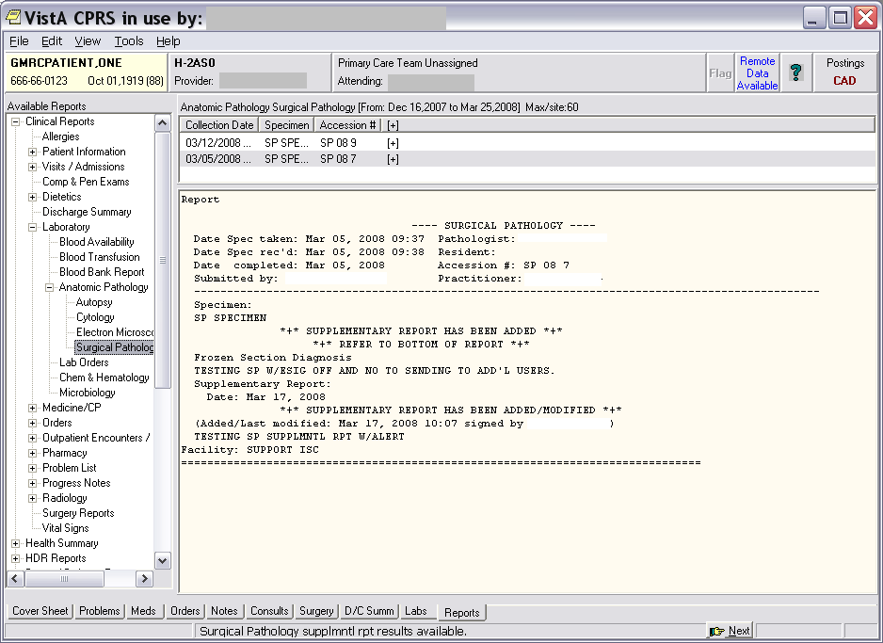
Example: ELECTRON MICROSCOPY displaying a SUPPLEMENTARY REPORT that has been added with ES ON, YES to send alerts to additional users, and a SUPPLEMENTARY REPORT has been Added/Modified.

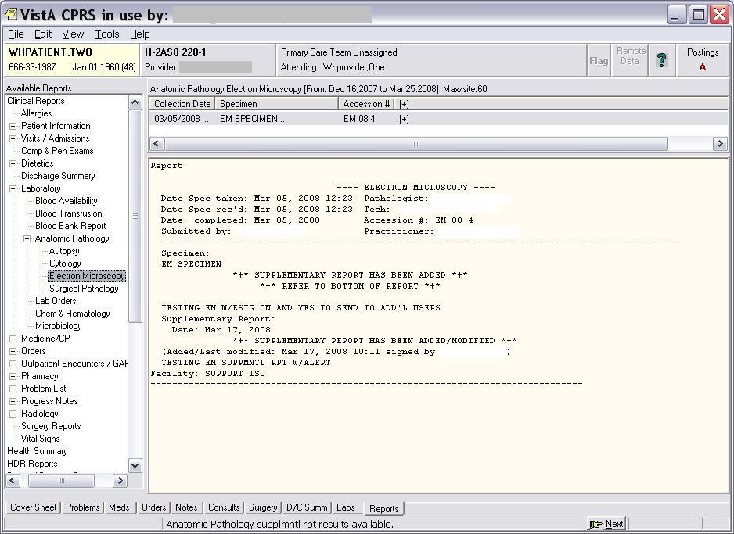
Example: AUTOPSY report displaying a SUPPLEMENTARY REPORT that has been Added/Modified and sending an alert.

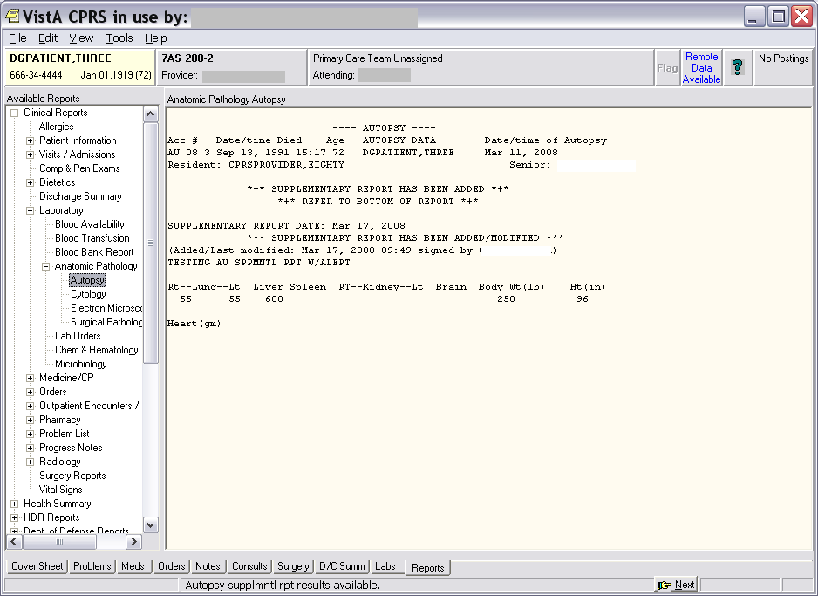

CPRS GUI Labs Tab, Lab Results views for AP Supplemental Reports

The following examples are displaying the Labs Tab, Lab Results for Cytopathology, Surgical Pathology, and Electron Microscopy Reports when a SUPPLEMENTARY REPORT has been added to a report:

Example: CYTOPATHOLOGY report displaying a SUPPLEMENTARY REPORT that has been Added/Modified with ES ON and YES to send alerts to additional users.

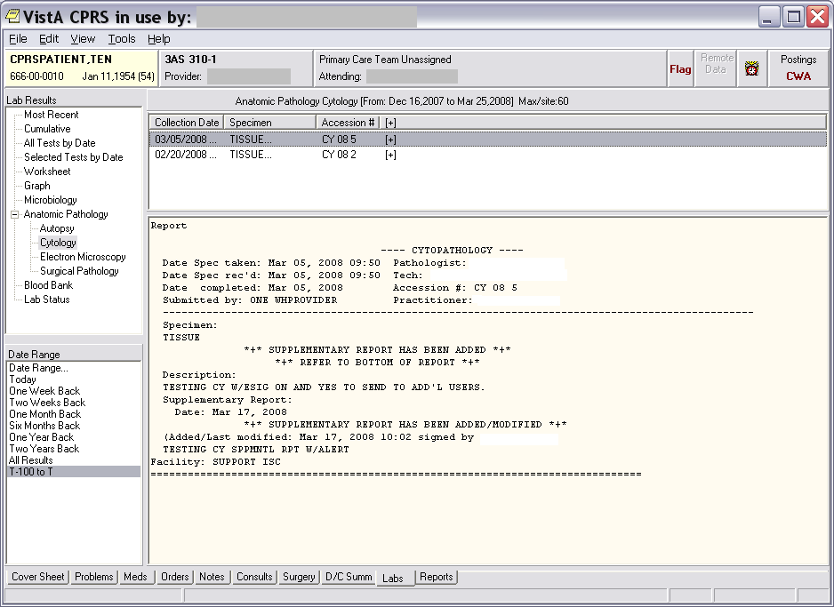
Example: SURGICAL PATHOLOGY report displaying a SUPPLEMENTARY REPORT that has been added with ES OFF, NO to send alerts to additional users, and SUPPLEMENTARY REPORT Added/Modified and YES to send alert.

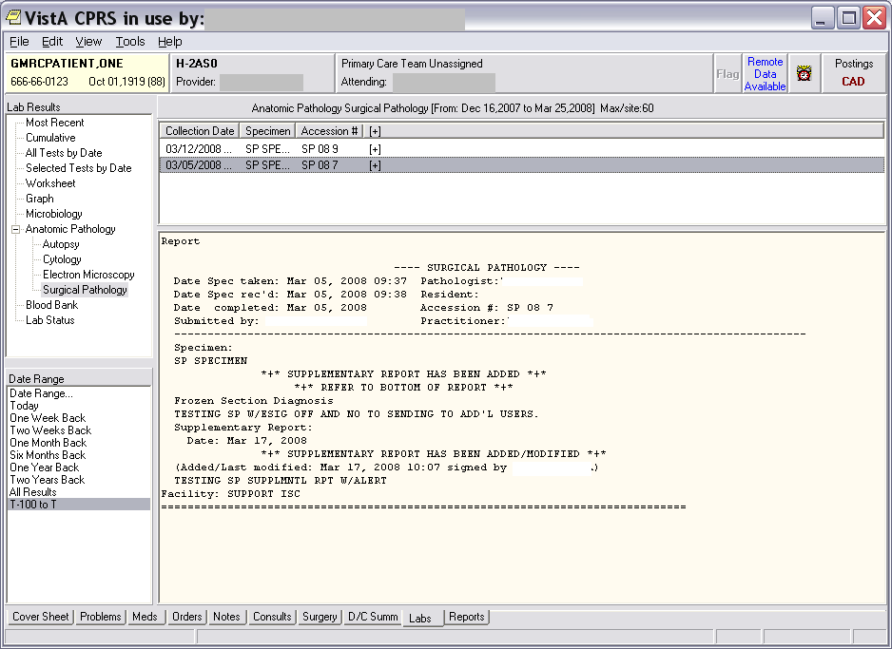
Example: ELECTRON MICROSCOPY report displaying a SUPPLEMENTARY REPORT that has been added with ES ON, YES to send alerts to additional users, and SUPPLEMENTARY REPORT Added/Modified and YES to send alert.

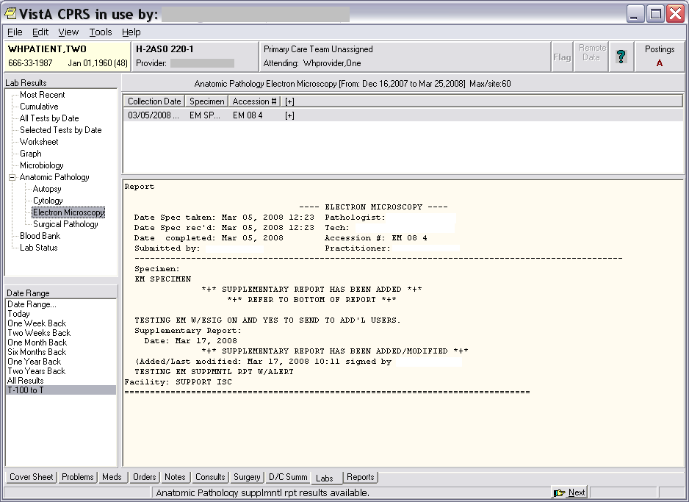
Example: AUTOPSY report displaying a SUPPLEMENTARY REPORT that has been added, SUPPLEMENTARY REPORT Added/Modified, and YES to send alert.

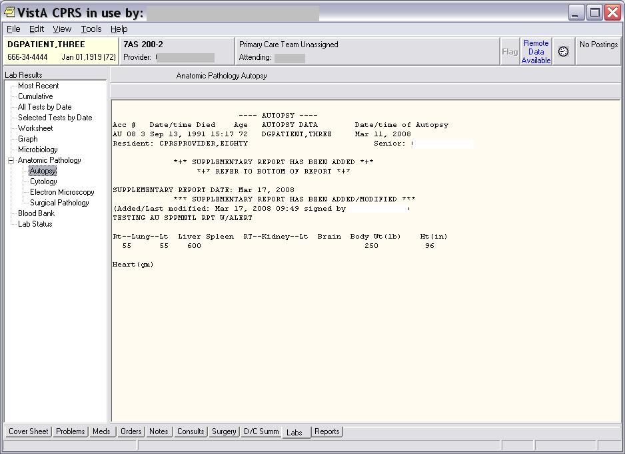

Glossary
This Glossary contains terms and their definitions, acronyms, and phrases that are used throughout the VistA Laboratory environments:

Glossary of Terms | Definitions
ADPAC: | Automated Data Processing Application Coordinator
AP: | Anatomic Pathology
API: | Application Program Interface
AU: | Autopsy
CPRS: | Computerized Patient Record System
CY: | Cytology
EM: | Electron Microscopy
ES: | Electronic Signature
GUI: | Graphic User Interface
HCS: | Health Care Systems
HL7: | Health Level Seven
KIDS: | Kernel Installation & Distribution System
LAN: | Local Area Network
LEDI: | Laboratory Electronic Data Interchange
MUMPS: | Massachusetts General Hospital Utility Multi-  Programming System
OI: | Office of Information
NLTF: | VA National Laboratory Test File
Glossary of Terms | Definitions
PIMS: | Patient Information Management System
PLMS: | Pathology and Laboratory Medicine Service
PSI: | Patient Safety Issue
PTF: | Patient Treatment File
SP: | Surgical Pathology
TCP/IP: | Transmission Control Protocol/Internet Protocol
TIU: | Text Integration Utilities
UI: | Universal Interface
VA: | Department of Veterans Affairs (never use DVA)
VAMC: | Department of Veterans Affairs Medical Centers
VAO: | VA Office
VISN: | Veterans Integrated Service Network
VistA: | Veterans Health Information Systems and Architecture

